## if I started the operation, then I want to stop the operation then I click on sign off

API Testing

1. <https://api.sap.com/api/sapdme_uom/overview> Click this link to API hub Screen.
2. Select the Rest API 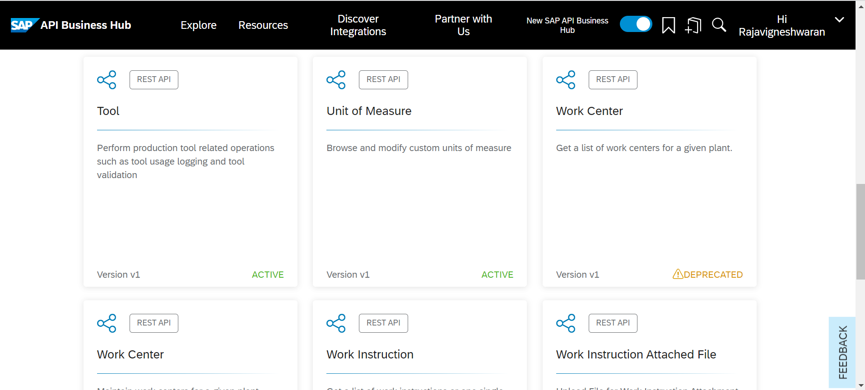
3. Select “Try Out”. 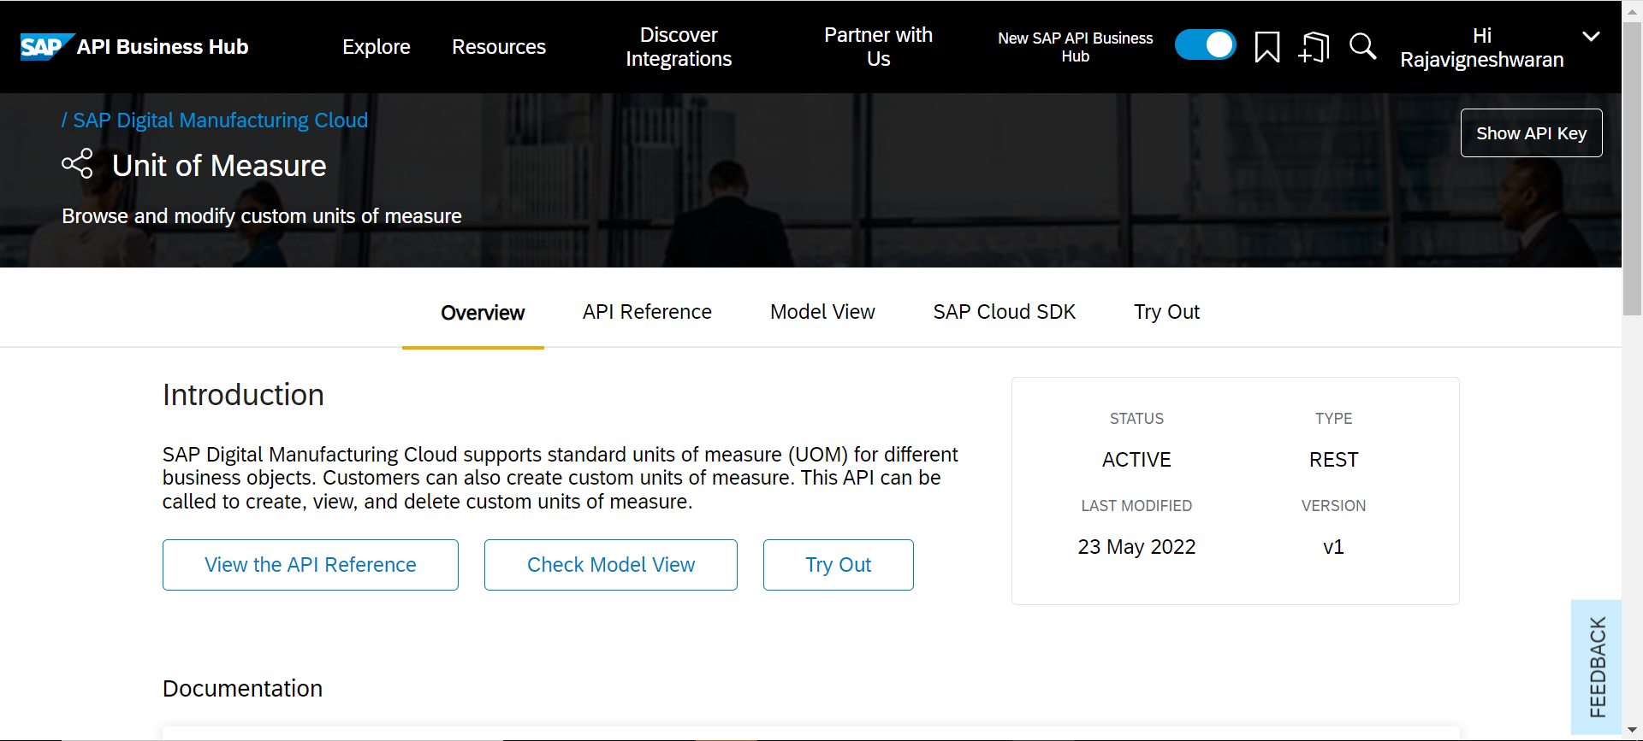
4. In left side, List of APIs available againts “UOM” 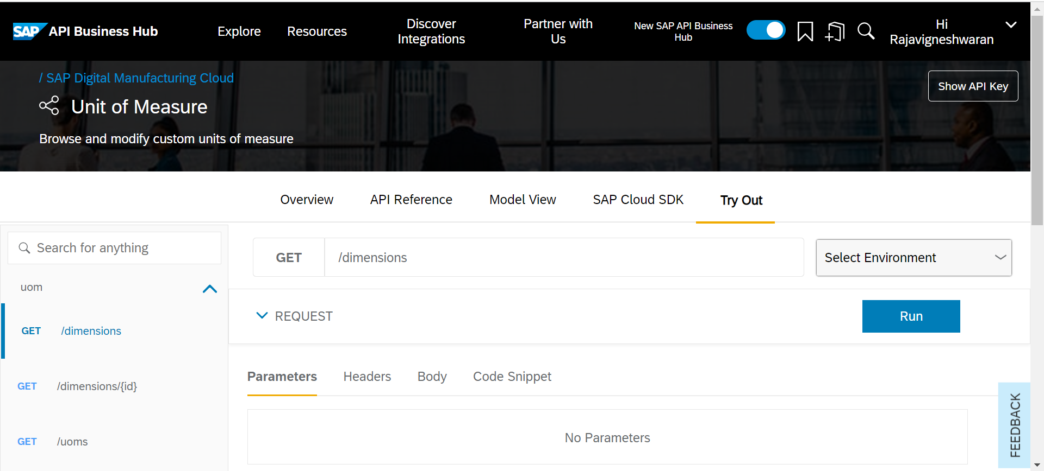
5. Select Environment and Click “Add New Environment”.

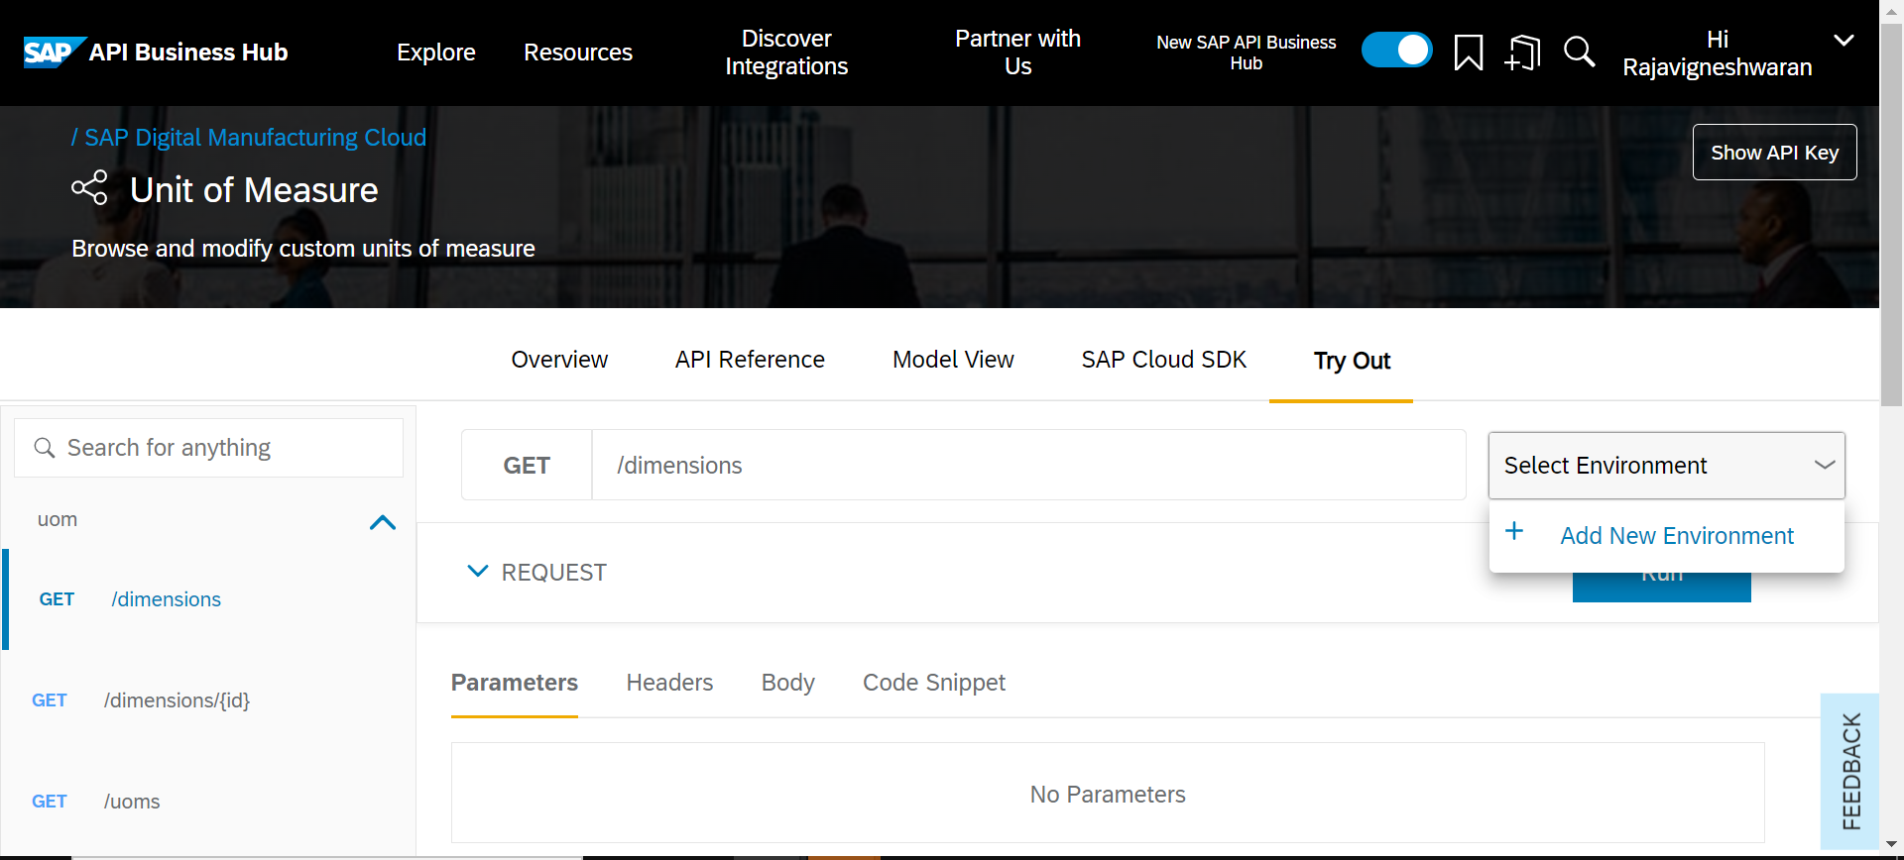

1. In Basic information, enter the Display Name and Starting URL. 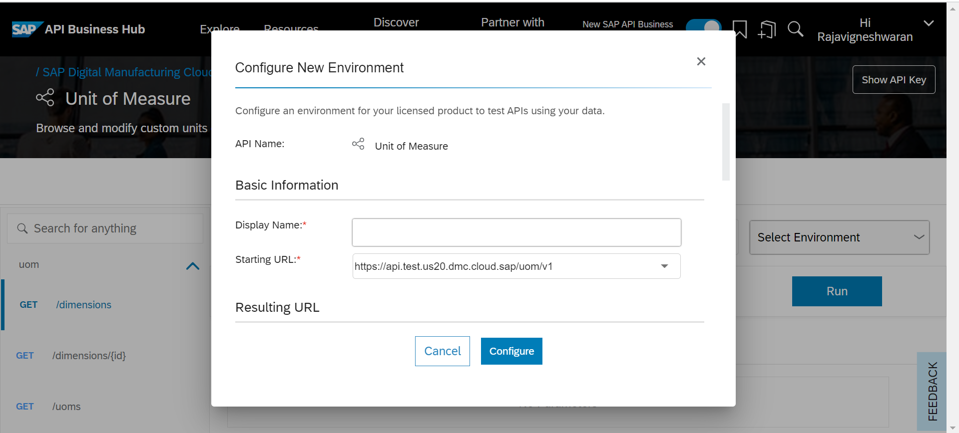
2. In Authentication, Enter the client ID, Client Secret ,Subdomain and select the TokenHost. 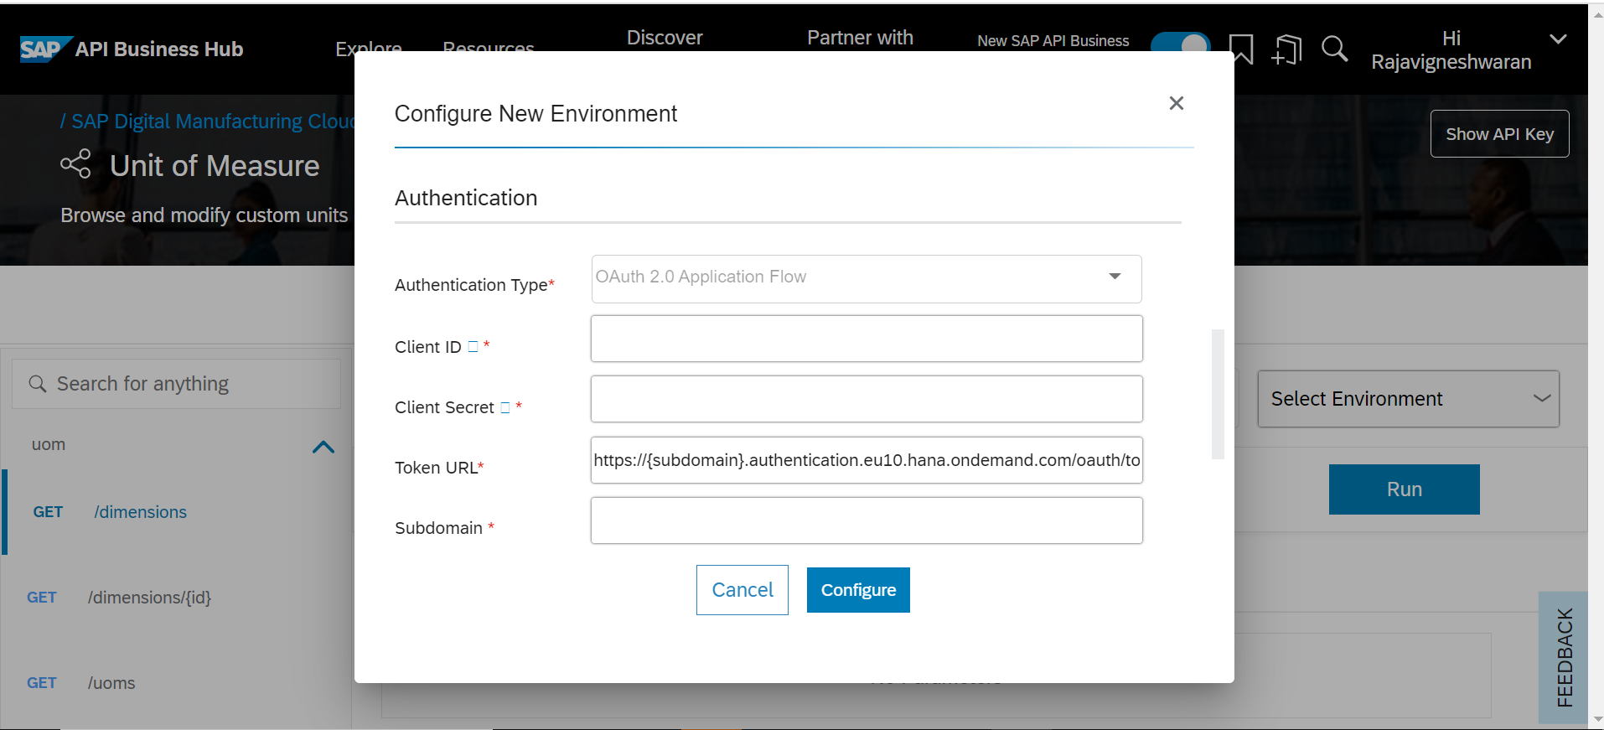

|  |  |
| --- | --- |
|  |  |
|  |  |

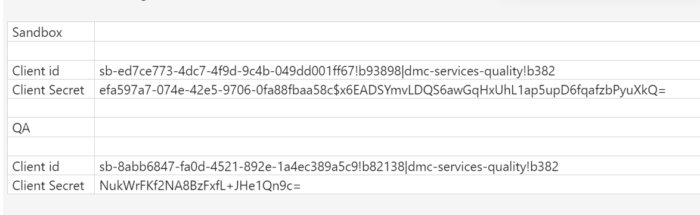

|  |  |  |
| --- | --- | --- |
|  | Sandbox |  |
|  |  |  |
|  | Client id | sb-ed7ce773-4dc7-4f9d-9c4b-049dd001ff67!b93898|dmc-services-quality!b382 |
|  | Client Secret | efa597a7-074e-42e5-9706-0fa88fbaa58c$x6EADSYmvLDQS6awGqHxUhL1ap5upD6fqafzbPyuXkQ= |
|  |  |  |
|  | QA |  |
|  |  |  |
|  | Client id | sb-8abb6847-fa0d-4521-892e-1a4ec389a5c9!b82138|dmc-services-quality!b382 |
|  | Client Secret | NukWrFKf2NA8BzFxfL+JHe1Qn9c= |

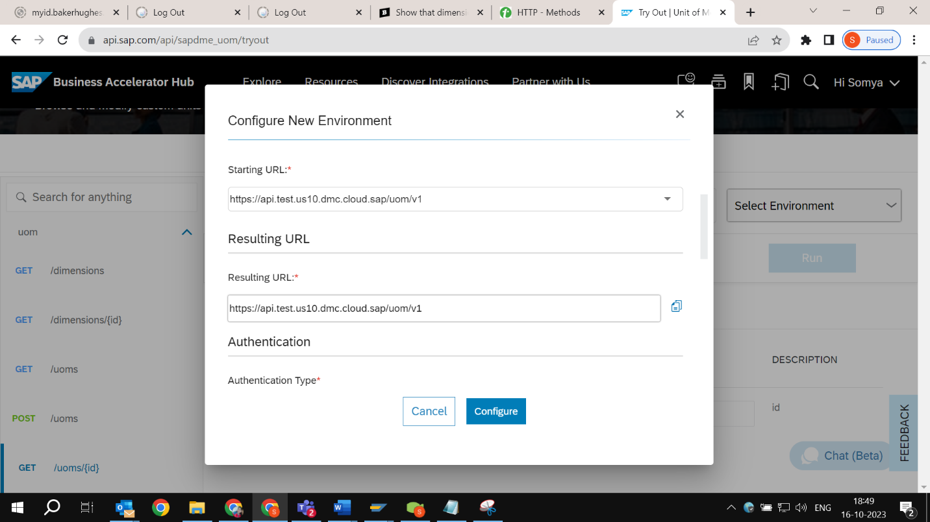

Subdomain :

1)**Sandbox**-bhdmc-sandbox-75zrxbav

2)**Test**-bhdmctest

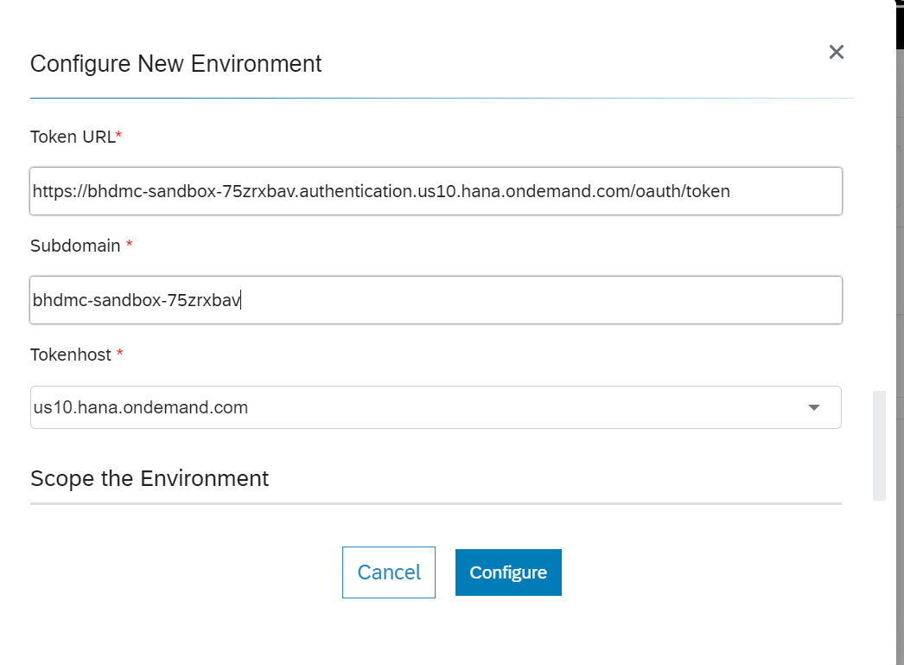

1. In Scope the Environment, Check the “Apply this environment to all APIs” checkbox and select the “Save this environment for future session” radio button. 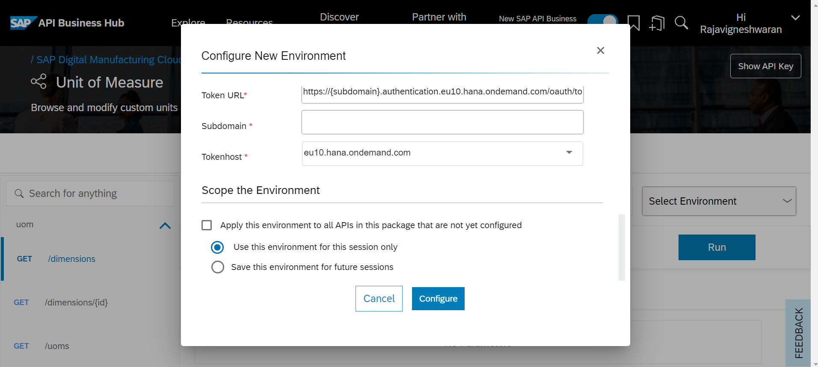
2. Enter the required parameters and Click run.

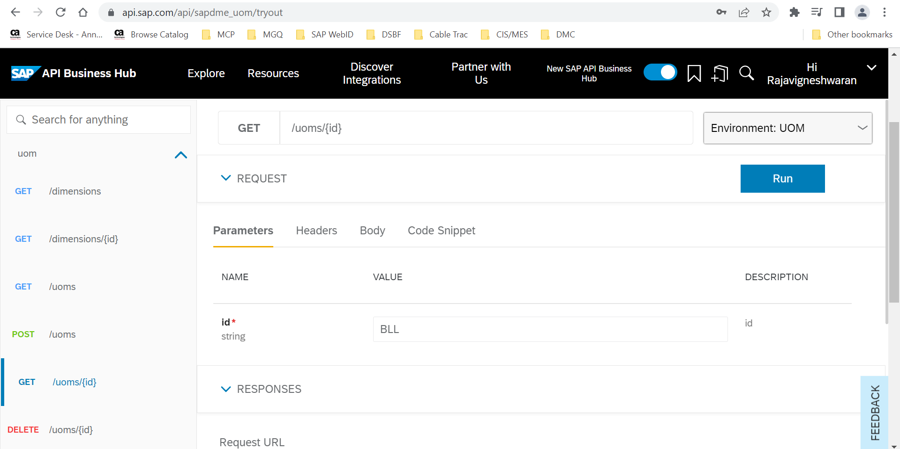

1. The output of the message will display in response body.

